Anypoint Platform Architecture

A document that describes the architecture for <<Company Name>>’s Anypoint Platform



|  |  |
| --- | --- |
| **Prepared by:** | Ashfaq Framewala |
| **Integration / Solution Architect (Client):** |  |
| **Senior Business Analyst:** |  |
| **C4E Leader:** |  |
| **Version:** | 0.2 |
| **Date:** | 30-Apr-2018 |

**Document Control**

Document history

|  |  |  |  |
| --- | --- | --- | --- |
| Version | Version Date | Updated by | Description of Changes |
| 0.1 | 01/11/2017 | Ashfaq Framewala | Initial Draft |
| 0.2 | 30/04/2018 | Ashfaq Framewala | Updated as per review comments on OBD KH |
|  |  |  |  |
|  |  |  |  |

**TABLE OF CONTENTS**

1 Introduction 6

1.1 Executive Summary 6

1.2 Purpose of this document 6

1.3 Intended Audience 7

2 Business Problems and Context 8

2.1 Context 8

2.2 Key Systems 8

2.3 Goals 8

2.4 Key Decisions 8

2.5 Assumptions and Dependencies 9

3 Platform Overview 9

3.1 <<Company’s>> License Subscription 9

3.2 Anypoint Platform Key Components 9

3.2.1 Design Center 10

3.2.2 Runtime 11

3.2.3 Connectors 11

3.2.4 Management Center 12

3.2.5 Exchange 12

3.3 Mule Runtime Requirements 12

3.4 Mule Runtime Connectivity Requirements (On-Premise) 13

3.4.1 Ports 13

3.4.2 Static IPs 14

3.4.3 Dynamic IPs 14

3.5 Setting up the Platform 15

3.5.1 VPCs (CloudHub) 15

**Sizing the VPC** 16

3.5.2 Business Groups (CloudHub) 17

3.5.2.1 Business Groups at <<Company Name>> 18

3.5.3 Environments at <<Company Name>> 18

3.5.4 Setting up Exchange Standards 18

4 Reference Architecture 19

4.1 Technology Reference Architecture 19

4.1.1 Deployment Architecture 19

4.1.2 Network Design (CloudHub) 21

4.1.3 Network Design (On-Premise) 22

4.1.4 Deployment view on CloudHub for Public APIs 23

4.1.5 Deployment view on CloudHub for Private APIs 24

4.1.6 Load Balancing on CloudHub 25

4.1.7 Load Balancing (on premise) 26

4.2 Application Reference Architecture 26

4.2.1 API Led Connectivity at <<Company Name>> 26

4.2.2 Architecture Patterns 27

4.2.3 Error Handling 31

4.2.3.1 Messaging Errors 31

4.2.3.2 About the Mule Error 32

4.2.3.3 About On-Error Scopes 34

4.2.3.4 System Errors 35

4.2.4 CI / CD Framework 36

4.2.4.1 CI / CD Components 36

4.3 Security Reference Architecture 37

4.3.1 Authentication and Authorization 38

4.3.2 Policies in API Manager 39

4.3.3 Other Policies that can be applied 39

4.3.4 List of policies 40

4.3.5 SSL Certificates 40

5 Non-Functional Requirements 42

5.1 Security 42

5.2 High Availability 42

5.2.1 High Availability Guide for CloudHub Deployments 42

5.2.2 High Availability Guide for On-Premise Deployments 44

5.3 Disaster Recovery 45

5.3.1 Disaster Recovery on CloudHub 45

5.3.2 Disaster Recovery On-Premise 47

5.4 Logging 48

5.4.1 Mule Application Logging 48

5.4.2 Integrate application logs with external monitoring / analytics tools 49

5.4.3 Audit Logging 50

5.4.4 Security Logging 51

5.4.4.1 API Policy Violations 51

5.4.4.2 API Usage Data 51

5.5 Alerting / Monitoring 51

5.5.1 Anypoint Runtime Manager (ARM) Server Alerts 51

5.5.2 Mule Runtime Manager Agent 52

5.6 Capacity Planning 53

# Introduction

## Executive Summary

The MuleSoft Anypoint Platform will be used by <<Company name>> as an API-led Integration Platform layer to connect to multiple on-premise and cloud based systems.

Mule Applications are created in the MuleSoft Anypoint platform to incorporate integration and business logic processes. This document is to provide details regarding the following:

* Reviewing and documenting functional and nonfunctional requirements
* Define a high-level platform Architecture
* Provide recommendations for the platform
* Provide best practices for delivering a Mule application
* Define the approach and best practices for an API Led Lifecycle Project.

This will significantly reduce the risks by ensuring the solution is designed right the first time and minimize the need for additional rework in the development phases and reducing the delivery time through quicker solution delivery leveraging the defined Best Practices.

This platform architecture document focusses on enabling designers and developers to start using the platform in the right way.

## Purpose of this document

This document presents an architecture for Anypoint Platform. The platform components will become the foundational building blocks for current and future API solutions at <<Company Name>>, where MuleSoft will be the primary platform for connectivity.

The document is not intended to provide the solution design and architecture for a particular project or API initiative, **this document describes a strategic architecture blueprint to design API solutions.**

## Intended Audience

The intended audience for this document includes the <<Company Name>> team comprising of the API Product Owners, Delivery Leads, Enterprise Architects, and Solutions Architects.

In addition to these roles, it is very important that the Business Teams (Business Analysts, Consultants, and Line of Business IT – LoBIT) are aware of this document and its content, as it describes many activities and processes that those roles are going to play in the delivery of APIs.

# Business Problems and Context

## Context

<<Provide a context about current Integration tools that the company is using and why they have chosen Anypoint Platform for connectivity in future>>

## Key Systems

<< Following table should list core systems that the company has and protocol with which integration is possible >>

|  |  |  |  |  |
| --- | --- | --- | --- | --- |
| **#** | **System Name** | **On-Premise / Cloud** | **Description** | **Protocol** |
| 1 | SalesForce | Cloud | Customer Relationship Management System | HTTP |

## Goals

<< Goals that the company intends to achieve using Anypoint Platform. If required, split this section into short term goals and long term goals>>

## Key Decisions

Following table lists the key decisions made.

|  |  |  |  |
| --- | --- | --- | --- |
| **Decision Area** | **Decision** | **Details** | **How does it impact** |
|  |  |  |  |
|  |  |  |  |

## Assumptions and Dependencies

<< List of assumptions and key dependencies >>

# Platform Overview

## <<Company’s>> License Subscription

The following describes the current subscription:

<<Needs to be updated as per subscription applicable>>

* Platinum Subscription
  + 24/7 Support
  + Hybrid which includes the option to switch on-premise cores to CloudHub vCores
* Anypoint Platform Components (Cloud based)
  + Anypoint Runtime Manager
  + Anypoint Exchange
* Pre-production Core x 4
* Production Core x 2
* API Manager & Analytics

## Anypoint Platform Key Components

Diagram below shows key components that form the Anypoint Platform.



## Design Center

Anypoint Design Center gives you the tools you need to build connectors, implement data and application integration flows, design and test APIs.

* Flow designer is the web-based interface for designing Mule applications for Anypoint Platform, which could be used by those who are new to integration. For experienced integrators, Anypoint Studio provides the right interface.
* API designer provides a web-based graphical environment for designing, documenting, and testing APIs. API designer also allows to create reusable API fragments that could be included in multiple API specifications.
* Anypoint Studio allows to build integration applications graphically or in XML. Anypoint Studio simplifies data transformations and mappings and it comes with strong debugging capabilities. Anypoint Studio also provides support for MUnit that should be used for unit testing the Mule applications.

## Runtime

Mule runtime is the Anypoint Platform engine, where the Mule applications are deployed to. <<Decision on using which version of Mule runtime should be documented here>>.

## Connectors

Anypoint Connectors provide a means to connect to endpoints from your integration applications. Connectors fall into different categories

| Type | Description |
| --- | --- |
| **Community** | MuleSoft or members of the MuleSoft community write and maintain the Community connectors Connectors built by the community or MuleSoft are generally open-source, although each package may vary. Partner-built connectors may not be open-source. Contact the partner directly for more information. You do not need any special account or license to use a Community connector. |
| **MuleSoft Certified** | [MuleSoft Certified connectors](https://anypoint.mulesoft.com/exchange/?search=mulesoft-certified) are developed by MuleSoft’s partners and developer community and are reviewed and certified by MuleSoft. For support, customers should contact the MuleSoft partner that created the MuleSoft Certified connector. |
| **Select** | MuleSoft maintains [Select connectors](https://anypoint.mulesoft.com/exchange/?search=select). Connectors included in the open source Mule distribution can be used by everyone, however support is only included in an Anypoint Platform subscription. To use all other Select Connectors and access support, you must have an active Anypoint Platform subscription. |
| **Premium** | MuleSoft maintains [Premium connectors](https://anypoint.mulesoft.com/exchange/?search=premium); you must have an active CloudHub Premium plan or an Enterprise subscription with an entitlement for the specific connector you wish to use. |

## Management Center

Anypoint Management Center provides a single web interface to administer all of Anypoint Platform, both on-premise and in the cloud. With Anypoint Management Center it is possible to Manage APIs and users, analyze traffic, monitor SLAs, troubleshoot underlying integration flows and more.

* With Runtime Manager, administrators can monitor status and state of deployments on Mule runtimes that are provisioned on-premise or on cloud. Other key features of Runtime Manager include ability to view performance metrics across environments, ability to create clusters or queue messages for scale and reliability, ability to set alerts and respond proactively to eliminate resource constraints and more
* API Manager enables you to manage users, monitor and analyze traffic, promote and secure APIs with ordered policies. Provide API management for every connection made to backend services and data sources with Mule runtime engine, a single runtime deployable as an integration engine and an API gateway.

## Exchange

Anypoint Exchange provides a central hub for saving, discovering, and reusing APIs and integration assets. With Anypoint Exchange, users can save API fragments, connectors, templates and examples at one location for other users in the organization to discover and reuse.

## Mule Runtime Requirements

<< Applicable only for On-Premise Deployments>>

Recommended minimum hardware is:

* 2GHz CPU or 1 virtual CPU in virtualized environments
* 1GB of RAM
* 4GB of storage

Adjust RAM to match your latency requirements and the size and number of simultaneous messages that applications process.

Software requirements are:

* One of the following Java versions:
  + Oracle JDK 1.8.0 (JDK 1.8.0_144 recommended)
  + IBM JDK 1.8
  + OpenJDK 8 (JDK 1.8.0_144 recommended)
* For Microsoft Dynamics GP connector install Java Cryptography Extension (JCE) 8 after installing JRE or JDK.

Mule Runtime is tested against operating systems listed in the "Supported Software and Systems" table at <https://docs.mulesoft.com/mule-user-guide/v/3.9/supported-sw-and-systems>.

<<Add a note on what type of server is chosen by the customer here. Also add a table stating how many servers are required in which environments>>

|  |  |  |  |
| --- | --- | --- | --- |
| Environment | Hardware | Mule Server, JDK Version & JVM Configuration | Notes |
|  |  |  |  |

## Mule Runtime Connectivity Requirements (On-Premise)

The following sections contain ports or IPs/hostnames for the communication between the Runtime Manager Agent and the Anypoint Runtime Manager

### Ports

The Runtime Agent requires outbound access to the Anypoint Runtime Manager for the following domains on port 443. Note this is an outbound WebSocket request from the Runtime Agent. For more information refer to the following link: <https://docs.mulesoft.com/runtime-manager/runtime-manager-agent-architecture>

| **Name** | **Port** |
| --- | --- |
| **anypoint.mulesoft.com** | 443 |
| **mule-manager.anypoint.mulesoft.com** | 443 |
| **analytics-ingest.anypoint.mulesoft.com** | 443 |
| **arm-auth-proxy.prod.cloudhub.io** | 443 |

### Static IPs

There are two Static IPs that needs to be whitelisted for mule-manager.anypoint.mulesoft.com hostname.

| **Name** | **IP Address** |
| --- | --- |
| **mule-manager.anypoint.mulesoft.com** | 52.201.174.72 |
| **mule-manager.anypoint.mulesoft.com** | 52.201.67.218 |

### Dynamic IPs

Some of the IP addresses used by Anypoint services are assigned automatically by the underlying cloud infrastructure, and hence we can’t guarantee that they are not going to change in the future.

For this reason, you should not implement a whitelist based on the specific IP addresses being assigned to Anypoint services.

Nowadays, many firewall devices allow you define Layer 7 Firewall Rules, where you could be able to filter by destination name or application type.

The hostnames that you should include in your Firewall rules are:

| **Hostname** |
| --- |
| **anypoint.mulesoft.com** |
| **analytics-ingest.anypoint.mulesoft.com** |
| **arm-auth-proxy.prod.cloudhub.io** |

## Setting up the Platform

### VPCs (CloudHub)

In order to properly configure a VPC for your account, you need to keep a few considerations in mind.

Defining a proper size for your VPC at the beginning is crucial since once a VPC is created you need to remove all your workers and redeploy them once the change is complete. In order to avoid unnecessary downtime, it is recommended to design your VPC to scale accordingly. More information can be found in the section below.

In order for the VPC to be able to host your Workers, it needs to be bound to a business group and a specific CloudHub region, and once it’s created, you need to redeploy your applications.

You also need to make sure that the firewall rules are configured according to your needs.

Once this is defined, you can proceed to create your VPC using:

1. The VPC UI available in your Runtime Manager section.
2. The Anypoint Platform CLI.

##### **Sizing the VPC**

When you create a VPC, the range of IP addresses for this network needs to be specified in the form of a Classless Inter-Domain Routing (CIDR) block, using CIDR notation.

In order to calculate the proper sizing for your VPC, you first need to understand that the number of dedicated IP addresses is not the same as the number of workers you have deployed.

For each worker deployed to CloudHub, the following IP assignation takes place:

* For better fault tolerance, the VPC subnet may be divided into up to 4 Availability Zones.
* A few IP addresses are reserved for infrastructure.
* At least two IP addresses per worker to perform at zero-downtime.

Due to this structure, the smallest network subnet block you can assign for your VPC is /24 and the largest /16. A /24 (CIDR notation) subnet has 256 IP addresses.

Reserving one IP address for the network and one for broadcast you have 254 hosts for your worker, which get divided into 4 availability zones of 62 hosts each. Consider that each worker potentially needs two IP addresses for zero-downtime, that’s around 30 IP addresses to assign to your workers.

<<Provide details on how many VPCs will get configured and if possible IP address range for each of them>>

|  |  |  |  |
| --- | --- | --- | --- |
| VPC name | Environment | Region | CIDR |
|  |  |  |  |

Refer to section 4.1.2 for details on how connectivity has to be established.

### Business Groups (CloudHub)

Business Groups provide a mechanism for delegating management and administration of Anypoint Platform to users within different business units or functions. Additionally, Business Groups provide complete isolation of resources allowing for multi-tenant use cases within your Anypoint Platform account.

Centralized administrators can create a multi-level, hierarchical structure of Business Groups and then delegate users from the specific groups to be administrators. These group administrators then have the ability to manage permissions and roles as needed within their group. Business group administrators can utilize external identity providers such as PingFederate or OpenAM to easily map external LDAP groups to roles within the Anypoint Platform. This simplifies management of permissions across Business Groups. Additionally, Business Groups administrators have the option of creating their own sub-groups and delegate administrators of those sub-groups

Business Group administrators only have visibility to the groups they manage. They cannot view or manage permissions for resources outside of their specific group.

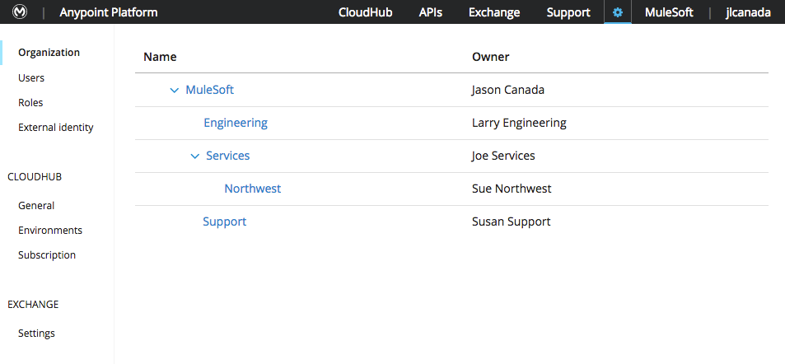

Figure : Business Groups

**Business Groups and CloudHub**

One large benefit of Business Groups for CloudHub customers is the ability to easily delegate vCore workers across Business Groups. This allows customers to have a single subscription to manage and easily track usage & chargebacks by business unit or project. When creating a Business Group administrators can easily select how many production and sandbox vCores are available for consumption. Administrators of the Business Group can then create additional sub-groups and further divide their vCore allotments to those lower levels.

### Business Groups at <<Company Name>>

<<Provide a list of Business Groups that are required and a split of vCores per business group.>>

|  |  |  |
| --- | --- | --- |
| Business Group Name | Description | vCores (Design, NonProd and Prod) |
|  |  |  |

### Environments at <<Company Name>>

<<Provide a list of Environments that are required>>

### Setting up Exchange Standards

Exchange provides a central hub for publishing and discovering APIs, templates and other reusable assets. It is important that each asset provides a clear, concise and valid description.

Following section provides some good practices that can be followed for different type of assets:

|  |  |
| --- | --- |
| Asset Type | Details to be provided in Exchange |
| API | * Description on what functionality is provided by the API - Mandatory * Description on resources, methods supported – Optional * Security policies applied to the API – Mandatory |
| API Fragment | * Type of fragment – Datatype, Trait, Example etc – Mandatory * Brief description on the fragment - Mandatory * If the fragment is small, paste contents of the API fragment - Optional |
| Template | * Description of the functionality covered by the template - Mandatory * User guide on how to use the template and what all changes are required – Mandatory |
| Example | * Description of the functionality covered by the example – Mandatory * User guide on how to setup and run the example - Mandatory |

# Reference Architecture

## Technology Reference Architecture

This section describes a set of artefacts and reusable assets that should be considered when architecting solutions at the technology layer, as well as some design decisions made at the platform layer that shape how the solutions will be deployed at the system, network and connectivity level.

### Deployment Architecture

For Deployment, if there are more than one options being discussed – Hybrid, On-Premise or Cloud – add a description of each of these options and recommended option.

E.g, - Deployment of all applications on CloudHub

CloudHub is a PaaS component of Anypoint Platform, providing a fully-managed, secure and highly available cloud platform for integration and APIs.

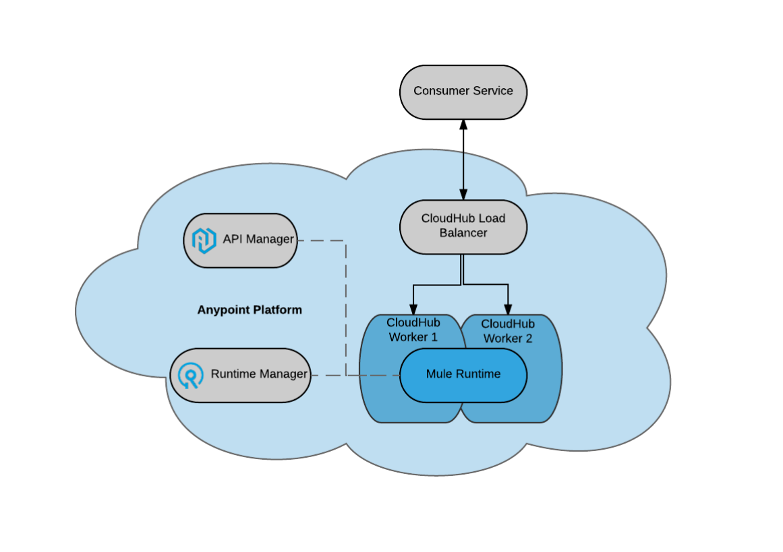

*Figure 10: CloudHub Deployment*

**Advantages of using CloudHub:**

1. With CloudHub, there won’t be any hardware to maintain and there will be continuous software updates provided in the platform.
2. Business Groups with CloudHub provide an added advantage for allocation of cores across business groups.
3. Disaster recovery for CloudHub workers provided by underlying AWS infrastructure.
4. Flexibility of choosing worker size depending on application requirement, that starts with 0.1 of a core.

### Network Design (CloudHub)

<< Provide a description on how AWS CloudHub VPC will connect to on-premise systems or Systems that are deployed on other Cloud Services.

Following is an example

The following picture depicts how network connectivity could be established between applications deployed on CloudHub, SaaS applications and applications/systems running on Dennis Family Corporation network.

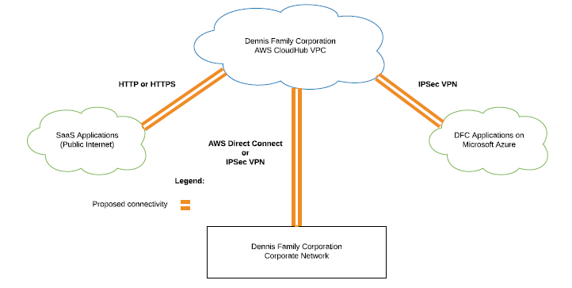

*Figure 11: Network Design*

As shown in the diagram above, there are different networks where Dennis Family Corporation systems / applications are deployed. Connectivity between these networks is described below.

For mule applications deployed on CloudHub which in turn runs on AWS, a VPC can be established for all Dennis Family Corporation CloudHub workers.

* CloudHub workers should be able to connect to publicly available SaaS application over HTTP or HTTPs.
* Connectivity between CloudHub VPC and Microsoft Azure could be established using IPSec VPN.
* Connectivity between CloudHub VPC and On-Premise could be established using AWS Direct Connect (preferred) or IPSec VPN.

Following sections provide technical details at high level for each of the options mentioned above.

**AWS Direct Connect:** Using AWS Direct Connect, you can establish private connectivity between CloudHub and your datacenter, office, or colocation environment, which in many cases can reduce your network costs, increase bandwidth throughput, and provide a more consistent network experience than Internet-based connections.

**IPSec VPN:** A virtual private network (VPN) provides a means for securely communicating among remote computers across a public WAN such as the Internet. A VPN connection can link two LANs (site-to-site VPN) or a remote dial-up user and a LAN. The traffic that flows between these two points passes through shared resources such as routers, switches, and other network equipment that make up the public WAN. To secure VPN communication while passing through the WAN, the two participants create an IP Security (IPsec) tunnel. Note that IPSec tunnels can be created using Open Source solutions.

### Network Design (On-Premise)

<<Provide a description on how connectivity between Mule Runtime that will be deployed on-premise and other key applications / systems can be established.>>

### Deployment view on CloudHub for Public APIs

Following diagram shows how an API gets deployed on CloudHub workers and how it can be exposed to consumers that are external to Dennis Family Corporation network.

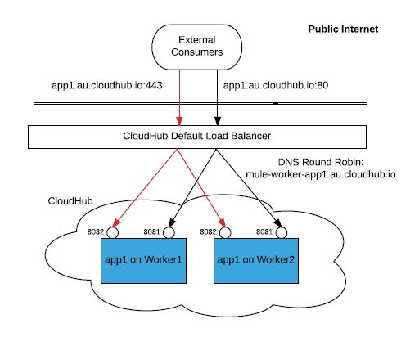

*Figure 12: Deployment view on CloudHub (Public APIs)*

The only two ports exposed externally are ${http.port} and ${https.port} (by default 8081 and 8082 respectively). If you wish to access other ports, you can do so through the **Anypoint Virtual Private Cloud (VPC)** offering.

The “http.port” property is automatically set to port 8081 for HTTP, and “https.port” is set to port 8082 for HTTPS. If other values for “http.port” and “https.port” are specified in the mule-app.properties file, these are overwritten at deployment time.

### Deployment view on CloudHub for Private APIs

If you wish to expose HTTP services only inside a VPC, these services can be exposed on ports ${http.private.port} ${https.private.port} (8091 and 8092 respectively), which are open by default on the internal network. In this case, these services are not accessible on the public IPs or the load-balancer, ensuring that they can be accessed securely.

In order to achieve load balancing for the application deployed on multiple workers, CloudHub Dedicated Load Balancer need to be configured.

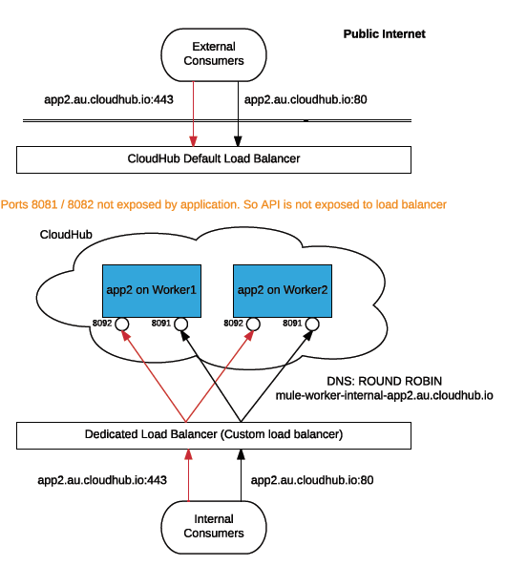

*Figure 15: Deployment view on CloudHub (Private APIs)*

### Load Balancing on CloudHub

Regarding Load Balancing, these are the design considerations:

* Default Load Balancer:
  + The default load balancer is always automatically provisioned. It is exposed to the public internet that does the LB to the workers that are in Fabric, mapping port 80 to 8081 and 443 to 8082.
* If the application is listening in the port 8081 or in the port 8082, the LB will redirect traffic to the application.
* If the application does not listen at port 8081 or 8082, the LB won’t be injecting any traffic to the application.
* Even when the application is launched with 1 single worker, the LB still gets provisioned.
* The default load balancer, when called to port 443 (SSL), exposes a default MuleSoft Server Certificate, and redirects the calls to port 8082 of the worker.
* The default load balancer, when called to port 80, redirects the calls to port 8081 of the worker.
* Dedicated Load Balancer:
  + There is an option to configure a Dedicated Load Balancer, which gives more flexibility of configuration, mapping multiple APIs to one “host:port”, use of a different SSL Server Certificate, etc.
  + With Dedicated Load Balancer, 2 way SSL can be enforced with the clients.
  + Also refer to section Deployment view on CloudHub for Private APIs.
  + Before using and/or configuring the Dedicated Load Balancer, please make sure that you have this entitlement in your Anypoint Subscription.

**Recommendation**: Looking at the features provided above by Dedicated Load Balancer, it is highly recommended to have it provisioned.

More information about the Networking Considerations in CloudHub, please visit:

<https://docs.mulesoft.com/runtime-manager/cloudhub-networking-guide>

### Load Balancing (on premise)

<< Explain how load balancing between APIs deployed on multiple runtimes will be achieved for on-premise deployments using loadbalancers like F5, NGINX or Netscaler etc. Also include details about clustering if Cluster has to be used>>

## Application Reference Architecture

### API Led Connectivity at <<Company Name>>

<< Provide a very high level view of how experience, process and System APIs will help integration of core systems.>>

<<Idea is to provide a view on how cores systems will integrate. Solution Architecture document should provide more details on exact number and design of APIs required>>

Example:

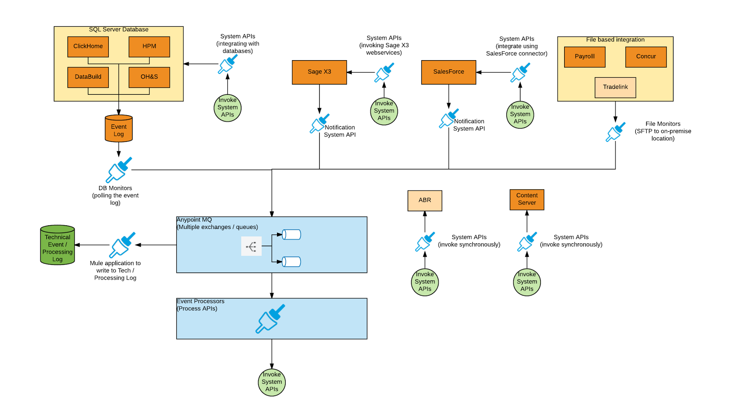

### Architecture Patterns

* + - 1. Asynchronous processing

In order to build highly scalable services, asynchronous processing is the recommended approach. If message delivery is a strong requirement, it is usually recommended to back the solution with a messaging framework (i.e. Anypoint MQ or JMS).

|  |  |
| --- | --- |
| Benefits | - Reliable processing (especially when backed with a messaging framework).  - High throughput.  - Highly scalable. |
| Drawbacks | - No on-line response to the service consumer.  - Tuning could be more complex. |

In case of Mule 4, flows always function synchronously. If you wish to achieve asynchronous type patterns such as fire and forget, you can use the <async> processor.

The Async scope is a branch processing block that executes simultaneously with the main flow. The main flow continues to execute while it initiates and processes the Async scope. The flow does not have to pause until the last message processor embedded in the asynchronous flow has completed its task.

Async can be useful for executing time-consuming operations that do not require you to send a response back to the initiating flow (such as printing a file or connecting to a mail server).

To facilitate simultaneous branch processing, the Async scope sends one copy of the message it has received to the first embedded message processor in its own processing block. At the same time, it sends another copy of the message to the next message processor in the main flow.

For more details on Async Scope, refer to <https://docs.mulesoft.com/mule-user-guide/v/4.1/async-scope-reference>

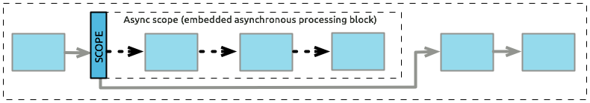

* + - 1. Synchronous processing (non-transactional endpoints)

HTTP-based REST APIs are the most commonly used non-transactional endpoints and by default implement request-reply pattern. Thus, it is important to acknowledge its drawbacks and take the actions necessary to minimize them.

|  |  |
| --- | --- |
| Benefits | - Best response time.  - Run on-line operations.  - Service client know immediately the result of the operation. |
| Drawbacks | - One thread needs to process the whole transaction.  - No transactional boundaries.  - Not suitable for large payloads. |

Mule 4 includes a new execution engine that is based on a non-blocking runtime. This is a task-oriented execution model allowing you to take advantage of non-blocking IO calls. By default, the flows always execute synchronously.

* + - 1. Synchronous processing (transactional endpoints)

Sometimes, it is necessary to process a number of steps that need to succeed or fail as a unit.

|  |  |
| --- | --- |
| Benefits | - Reliable processing.  - Allows defining a number of steps that have to succeed or fail as a unit.  - Service client know immediately the result of the operation.  - Enables Rollback Exception Strategy to handle exceptions. |
| Drawbacks | - Performance bottleneck.  - Resource intensive.  - One thread needs to process the whole transaction.  - Only certain connectors support transactions (see documentation for a complete list) |

When a series of steps in a flow must succeed or fail as one unit, Mule uses a transaction to demarcate that a unit. For example, you might use a transaction to encapsulate several steps in a flow that result in committing information to a database. In this type of scenario, the commit (or transaction) is either entirely complete and succeeds or is incomplete and fails. Even if partially complete, the commit fails. When a transaction fails, Mule rolls back the operations within the transaction so that no one part results in partial completion.

There are 2 ways in which transactions can be specified:

1. Through a Try scope
2. Through a message source

Details on Transaction Management can be found at <https://docs.mulesoft.com/mule-user-guide/v/4.1/transaction-management>

* + - 1. Batch processing

Mule allows you to process messages in batches. Within an application, you can initiate a batch job scope that splits large or streamed messages into individual records, performs actions upon each record, reports on the results, and potentially pushes the processed output to other systems or queues.

The heart of Mule’s batch processing lies within the batch job scope. A batch job is a scope that splits large messages into records. This way, the runtime can process such large messages asynchronously.

Just as flows process messages, batch jobs process records. A batch job contains one or more batch steps that act upon records as they move through the batch job.

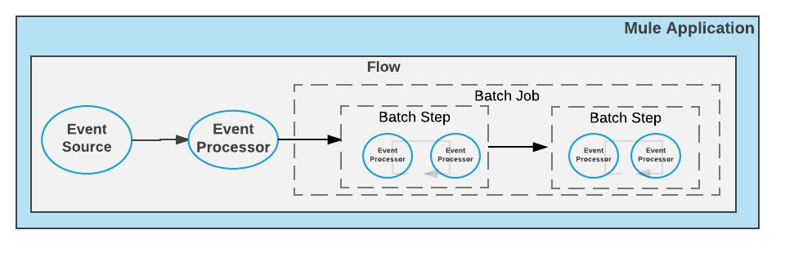

For more details on batch processing, refer to <https://docs.mulesoft.com/mule-user-guide/v/4.1/batch-job-concept>

* + - 1. Cloud Messaging (Event-Driven)

Anypoint MQ is a multi-tenant, cloud messaging service that enables applications to perform advanced asynchronous messaging scenarios. Anypoint MQ is fully integrated with Anypoint Platform, offering role based access control, client application management, and connectors.

Anypoint MQ includes the follow features,

* Queues and Message Exchanges: Send messages to queues, pull messages from queues, create a message exchange to perform pub/sub scenarios and send a message to multiple queues.
* Management console: Monitor queue statistics, purge queues, and see how many messages are in flight via the management console.
* Anypoint MQ connector: Send and receive messages from any Mule application, whether it’s deployed in CloudHub or used in a hybrid scenario and deployed on-premises.
* Usage information: Organization administrators or owners can view the current and past month’s usage - the total number of messages and API requests. This information is accessed from the Access Management page. For more information, see [Anypoint MQ Usage Information](https://docs.mulesoft.com/anypoint-mq/mq-usage).
* REST API: Use the REST API to easily communicate with non-Mule applications.
* Environments and role based access control: Anypoint MQ is fully integrated with Anypoint Access Management, allowing you to specify different environments for your queues, who can access each environment, and what they can do within each environment.
* Client management: Create client applications tokens.
* Large payloads: Anypoint MQ supports payloads up to 10 MB in size.
* Disaster recovery and multi-data center availability: Anypoint MQ provides persistent data storage across multiple data centers, ensuring that it can handle data center outages and have full disaster recovery.
* Encrypted queues: Queue data can optionally be encrypted, ensuring that companies can be compliant with their data at rest policies. Anypoint MQ uses PBE with MD5 and DES to encrypt messages.

**Advantages of using Anypoint MQ:**

1. Anypoint MQ provides cloud messaging service that performs advanced asynchronous messaging scenarios between applications.
2. Anypoint MQ supports hybrid use cases, IoT where you collect data from different devices, and a REST API you can use with device applications.
3. Anypoint MQ is fully integrated with Anypoint Platform, meaning that queues and message exchanges offer the same management capabilities as the platform itself, from environments and business groups for multi-tenant role-based access control to client access management.
4. Provides fully hosted and managed queues and message exchanges in the cloud.

### Error Handling

From a high level perspective, errors that occur in Mule fall into one of two categories: system errors and messaging errors.

### Messaging Errors

Mule throws a messaging error whenever a problem occurs within a flow. This error is known as a Mule Error. These errors are handled by the Error Handler component. The Error Handler can enclose On-Error Scopes that you can implement to handle specific errors in your flow. By default, unhandled errors will be logged and propagated.

When a Mule Event that is getting processed through a Mule flow raises an error, the normal flow execution stops, and the process is transferred to the Error Handler component. Inside the Error Handler component, you can incorporate various On Error scopes designed to match error types and expressions. Within each On Error scope that you configure, you can define an error path that incorporates any number of event processors to handle the error as precisely as you want. The error handler will route errors to the first On Error scope that matches it.

The diagram below illustrates what happens when an event processor throws a Mule error.



Figure : Mule error propagation

### About the Mule Error

Mule execution failures result in a Mule Error. Each Mule Error has the following components:

| Component | Description | Expression |
| --- | --- | --- |
| Description | A description regarding the problem | #[error.description] |
| Type | A type, used to characterize the problem and allow routing within an error handler | #[error.errorType] |
| Cause | The underlying Java Throwable that resulted in the failure | #[error.cause] |
| Message | An optional Mule Message regarding the problem | #[error.errorMessage] |
| Child Errors | An optional collection of inner errors, used by elements like Scatter-Gather to provide aggregated route errors. | #[error.childErrors] |

Each component in a Mule application declares the type of errors it throws so it’s easy for you to identify potential errors when designing a Mule flow.

For example, when an HTTP request fails with a 401 status code, the Mule Error looks like this:

*Description: HTTP GET on resource ‘http://localhost:36682/testPath’ failed: unauthorized (401)*

*Type: HTTP:UNAUTHORIZED*

*Cause: a ResponseValidatorTypedException instance*

*Error Message: { "message" : "Could not authorize the user." }*

**Error Types**

In the example above, the error type is HTTP:UNAUTHORIZED, not simply UNAUTHORIZED.  
Error types consist of both a namespace and an identifier, allowing you to distinguish the types according to their domain. For example, there are HTTP:NOT_FOUND and FILE:NOT_FOUND error types.

While connectors define their own namespace, core runtime errors have the implicit MULE one. So MULE:EXPRESSION and EXPRESSION are interpreted as one.

Another important characteristic of error types is that they may have a parent type. For example, HTTP:UNAUTHORIZED has MULE:CLIENT_SECURITY as the parent, which, in turn, has MULE:SECURITY as the parent. This establishes error types as specifications of more global ones: an HTTP unauthorized error is a type of client security error, which is a type of a more broad security issue.

These hierarchies allow routing to be more general. For example, a handler for MULE:SECURITY catches HTTP unauthorized errors as well as OAuth errors.  
Below you can see what the core runtime’s hierarchy looks like:

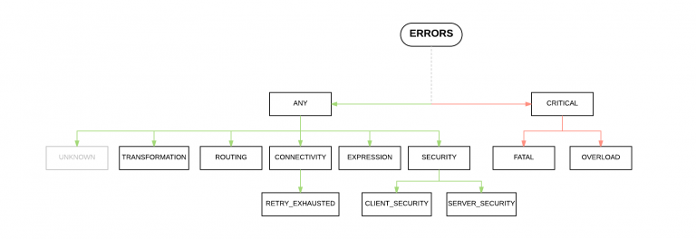

Figure : Mule Error

### About On-Error Scopes

On-error scopes are defined within error handlers. They define the type or group of types of error it handles. So when an error occurs, the error-handler component routes the Mule error to the first on-error scope that matches the error.

At this point, the error is available for inspection, so the on-error scopes can execute and act accordingly.

Mule supports two types of On Error Scopes. Both allow conducting matching through an error type (or group of) or through an expression (for advanced use cases). Each scope defines a different behavior for when an error occurs, which will affect the outcome of it’s owner (the flow or try scope where the error handler is defined):

|  |  |
| --- | --- |
| On Error Scope | Description |
| On Error Propagate | Executes but propagates the error to the next level up, breaking the owner’s execution. If a transaction is being handled, it’s rolled back.  https://docs.mulesoft.com/mule-user-guide/v/4.1/_images/error-handling-e77ec.png |
| On Error Continue | Executes and uses the result of the execution, as the result of its owner, as if the owner had actually completed the execution successfully. If a transaction is being handled, it would be committed as well. |

Each On Error Scope can be set up to accept a different set of error types. Both in Studio and Design Center, you can pick from a list of errors that could be raised by the components used in the error handler’s owner.

### System Errors

Mule throws a system error when an exception occurs at the system level. If no Mule Event is involved, the errors are handled by a system error handler.

A system error handler handles exceptions that occur:

* During application start-up.
* When a connection to an external system fails.

When a system error occurs, Mule sends an error notification to registered listeners, logs the error, and if the error was caused by a connection failure, executes a reconnection strategy.

System error handlers are not configurable in Mule.

### CI / CD Framework

It is recommended that deployment of Mule applications is done using a CI / CD framework. This section describes a high-level overview of the components that help in building a generic framework. More components might be added depending on specific requirements for a client.

### CI / CD Components

The main components are:

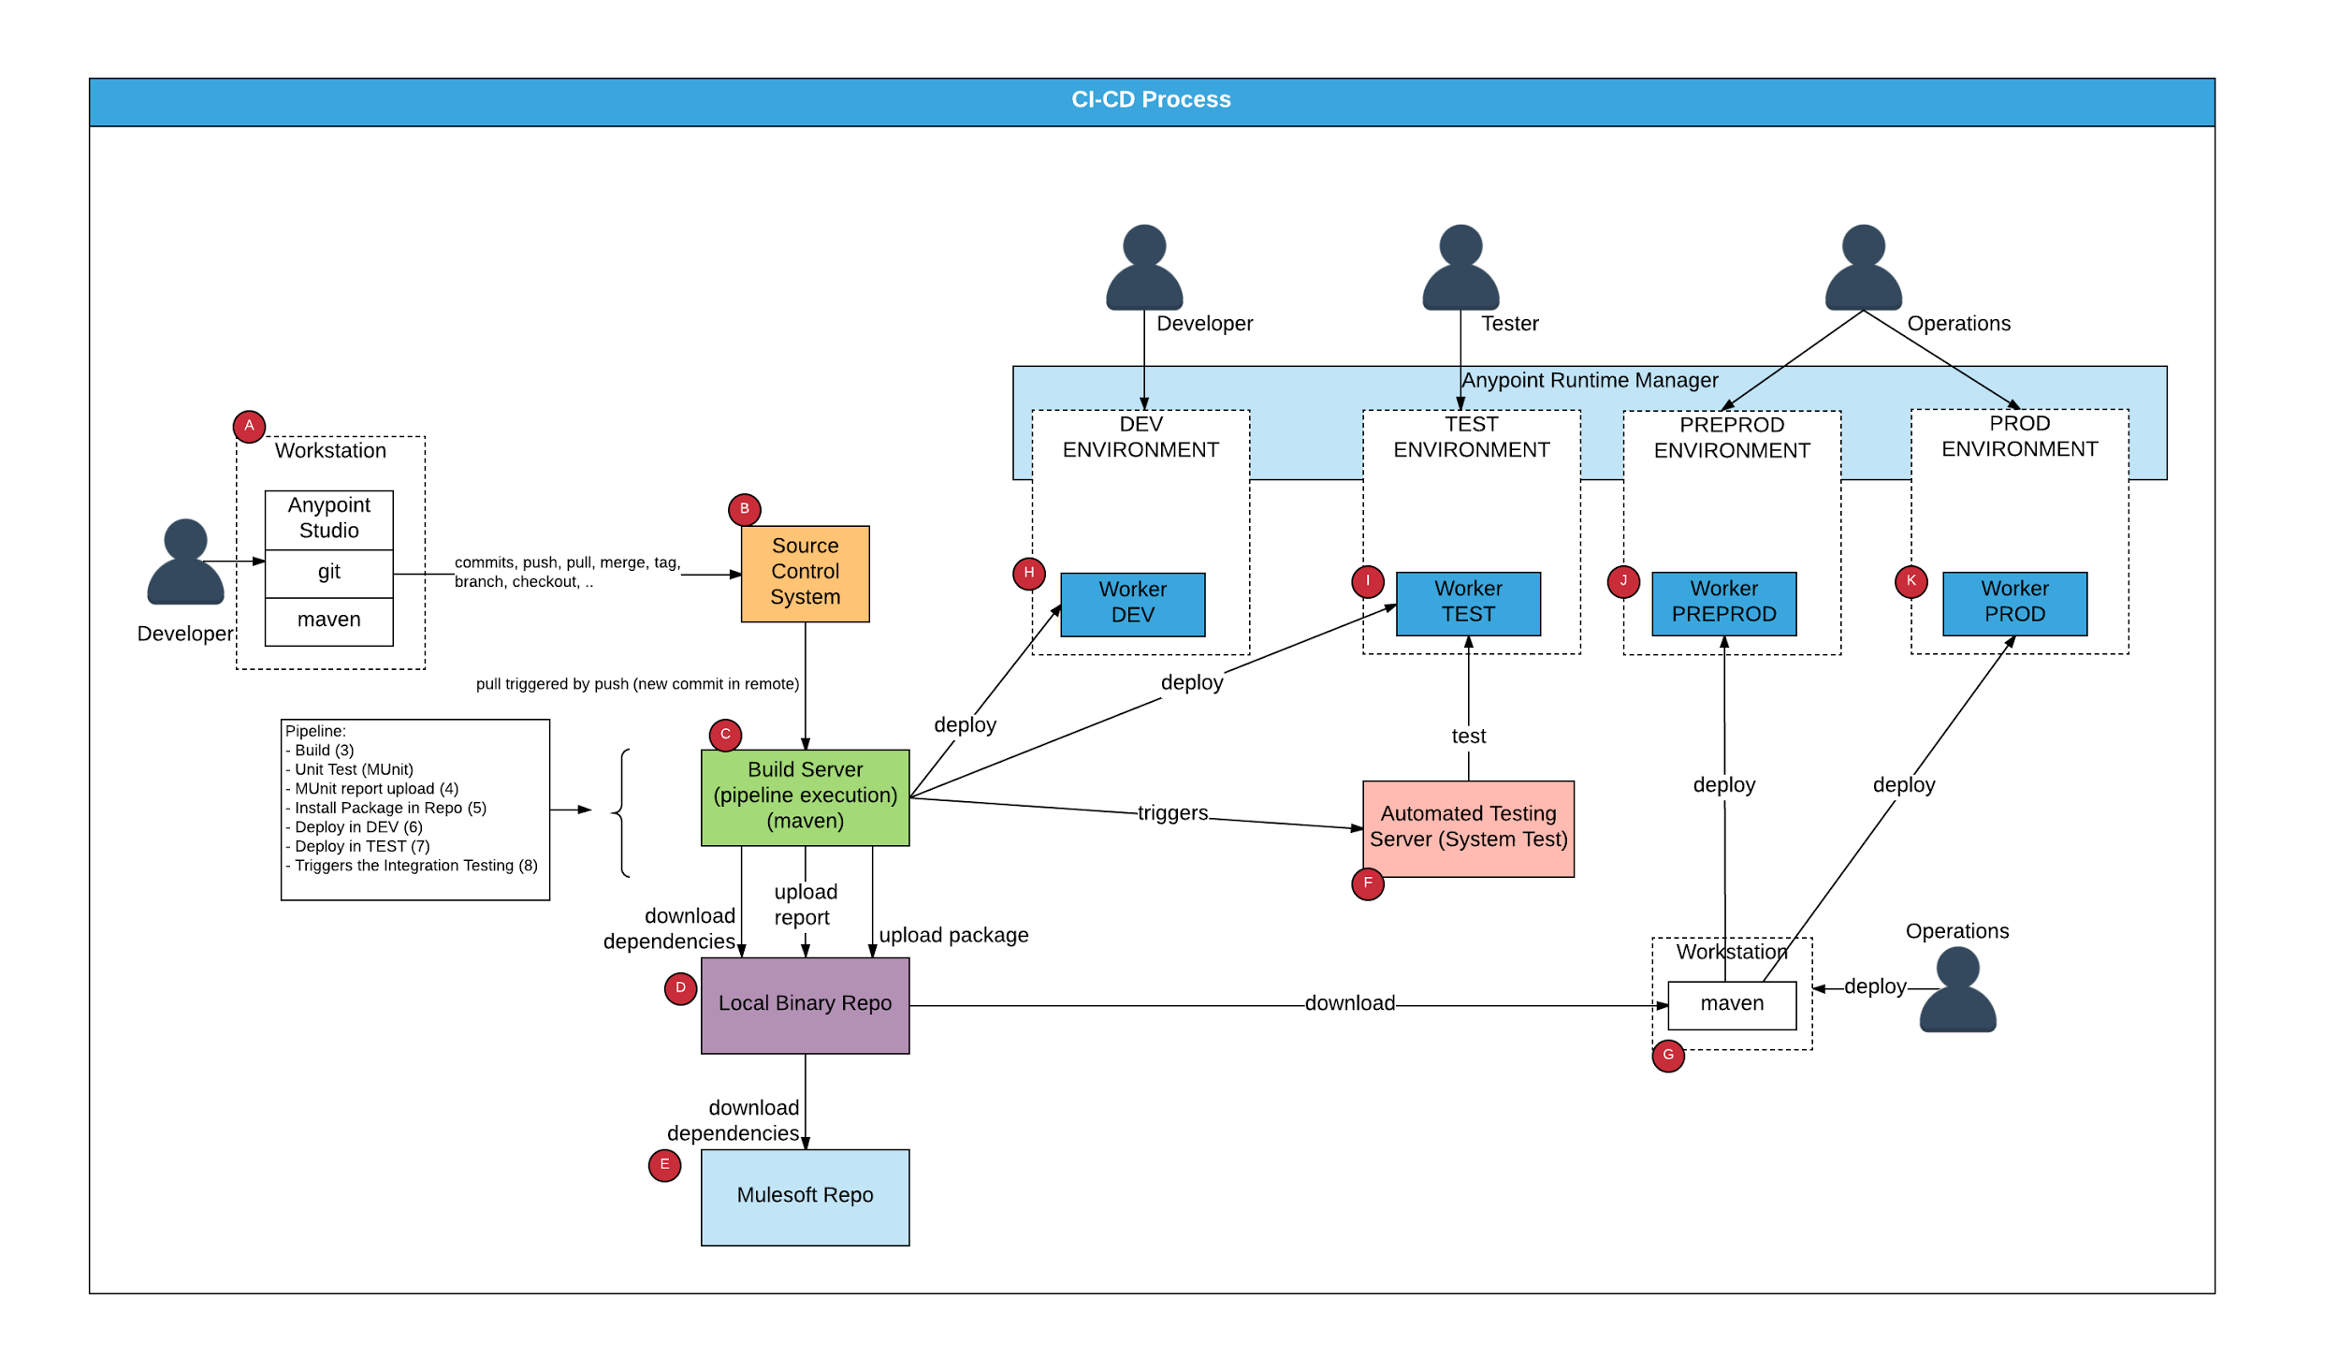

Figure : CI / CD Components

1. Developer workstation, where the pom.xml of the application is created and developed using Anypoint Studio and Maven.
2. Source Control System
3. Build Server, in charge of executing the pipeline to build. The basic tasks to execute are:
   1. Build the application (mvn package)
   2. Unit Test (mvn test)
   3. MUnit report upload
   4. Install package in repo (mvn install)
   5. Deploy into DEV (mvn mule:deploy)
   6. Deploy into TEST (mvn mule:deploy)
   7. Trigger the Integration Testing
4. Local binary repository, it should be compatible with Maven in order to retrieve and upload the artefacts created. This binary repository also can be configured to proxy the request to the official MuleSoft repository, so the packages released officially by MuleSoft can be cached locally. - TBD
5. MuleSoft official EE Maven Repository. This repository holds and it is used to download the official released MuleSoft components used in the applications.
6. Automated Testing Server. This server is used to automate functional, regression and performance testing of the APIs.
7. Operator Workstation: The operator who is in charge of deploying to PREPROD and PROD environments needs an environment with maven installed in order to execute the command mvn mule:deploy to deploy the applications to PREPROD and PROD.
8. Development environment.
9. Test Environment.
10. Preprod Environment.
11. Prod Environment.

## Security Reference Architecture

The following section describes and addresses the concerns related with security and potential options how to implement security mechanisms. It covers 4 main basic security requirements (Authentication, Authorization, Confidentiality and Integrity) and the solution to implement them in any API developed and deployed.

Every mule application exposing an API will be secured using API Manager, which enables to

manage in real-time the security policies applied to the mule applications.

<<Modify below diagram as per applicable systems and applications>>

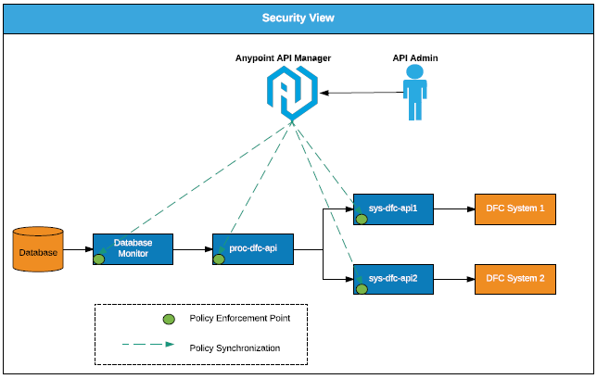

The policy enforcement points are continuously synchronizing the policies to enforce, via API Manager. That is why the policies can be applied in real time without restarting the applications.

### Authentication and Authorization

Every API call to any application settled in any layer will be authenticated. The simplest method selected to proceed with the authentication is the usage of client credentials (client_id, client_secret). These client credentials will be submitted by the client system that is invoking any Mule API, in particular when APIs are invoking other APIs.

There are other ways of authentication, like the usage of OAuth 2.0 with JWT token. <<If the customer wishes to implement authentication via JWT Tokens, an explanation should be provided on how JWT token validation will be done.>>

### Policies in API Manager

The policy configured in API Manager to enforce authentication and authorization will be “Client ID enforcement”

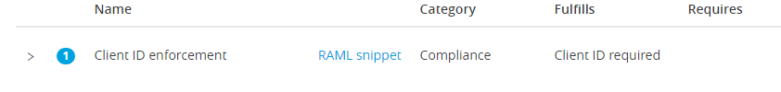

### Other Policies that can be applied

There are other policies available in the API Manager to apply to the mule applications if there are other security related or SLA related requirements associated: Note that some of these policies require an external identity manager.

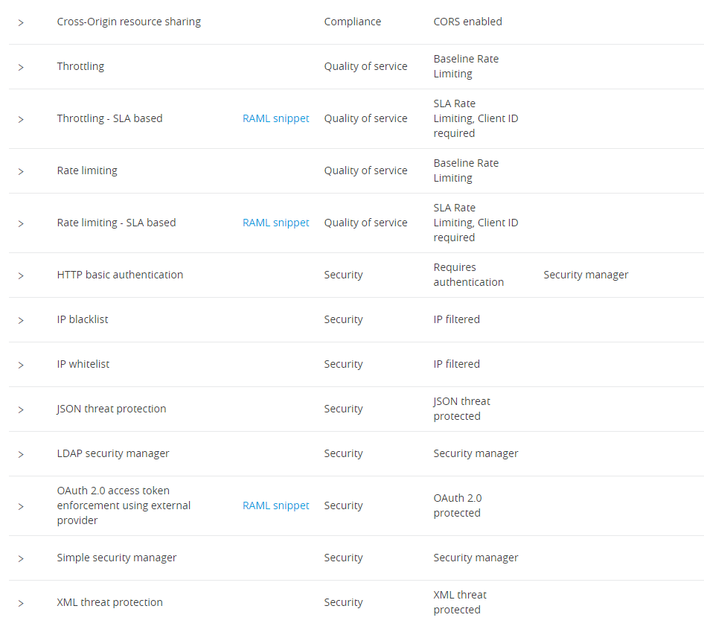

*Figure 17: API Manager Policies*

### List of policies

<<Provide a list of policies that will be used and scenarios where these policies will be used>>

### SSL Certificates

All the communications between mule applications will be secured using the HTTPS / JDBC over SSL / TCP over SSL / JMS over SSL. This will ensure the security requirements of:

* Authentication (server side authentication)
* Confidentiality
* Integrity

Note that in general, SSL certificates signed by a CA are considered as more trust worthy rather than self-signed certificates. The security team needs to recommend the correct certificates to be used for any project.

# Non-Functional Requirements

## Security

Security reference architecture section above covers how APIs can be made secure.

## High Availability

## High Availability Guide for CloudHub Deployments

CloudHub has been designed to be highly available and scalable through redundancy, intelligent healing, and zero downtime updates. It also provides customers with the ability to scale and have added reliability through [CloudHub Fabric](https://docs.mulesoft.com/runtime-manager/cloudhub-fabric).

**Intelligent Healing**

CloudHub monitors the worker clouds for any type of problems and provides a self-healing mechanism to recover from problems. If the underlying hardware suffers a failure, the platform migrates your application to a new worker automatically. In the case of an application crash – whether due to a problem with custom code or a bug in the underlying stack – the platform recognizes the crash and can restart the worker automatically.

For more information about application monitoring and automatic restarts, see [Worker Monitoring](https://docs.mulesoft.com/runtime-manager/worker-monitoring).

**Zero Downtime Updates**

CloudHub supports updating your applications at runtime so end users of your HTTP APIs experience zero downtime. While your application update is deploying, CloudHub keeps the old version of your application running. Your domain points to the old version of your application until the newly uploaded version is fully started. This allows you to keep servicing requests from your old application while the new version of your application is starting.

**CloudHub Fabric**

CloudHub Fabric provides scalability, workload distribution, and added reliability to applications on CloudHub. These capabilities are powered by CloudHub’s scalable load-balancing service, CloudHub Fabric worker scale-out, and persistent queuing features.

**Worker Scale-Out and Data Center Redundancy**

With CloudHub Fabric, you can add multiple workers to your application to make it horizontally scale. This also adds additional reliability. CloudHub automatically distributes multiple workers for the same application across two or more datacenters for maximum reliability.

When deploying your application to two or more workers, the HTTP load balancing service distributes requests across these workers, allowing you to scale your services horizontally. Requests are distributed on a round-robin basis.

**Persistent Queues**

Persistent queues ensure zero message loss and allow you to distribute non-HTTP workloads across a set of workers. For example, if your application is deployed to more than one worker, persistent queues allow inter-worker communication and workload distribution. If a large file is placed in the queue, your workers can divide it up and process it in parallel.

Persistent queues also guarantee delivery of your messages; even if one or more workers or datacenters go down, persistent queues facilitate disaster recovery and provide resilience to hardware or application failures.

**Object Stores**

Certain CloudHub modules - object store, application settings and Insight related information are maintained in the US East for all applications irrespective of the region they are deployed in. If the US East region comes down, the object stores would not be available and data within the object store is reset once the region comes back.

There is a risk that if US East Region goes down the data store in object stores will be lost. However, the possibility of the region not being available is significantly low and so the risk associated also is low.

## High Availability Guide for On-Premise Deployments

Mule Runtime High Availability (HA) Cluster Overview

A **cluster** is a set of Mule runtimes that acts as a unit. In other words, a cluster is a virtual server composed of multiple nodes. The nodes (Mule runtimes) in a cluster communicate and share information through a distributed shared memory grid. This means that the data is replicated across memory in different physical machines.

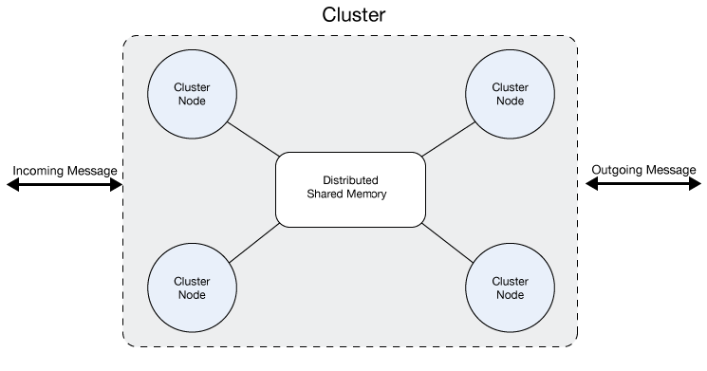

By default, clustering Mule runtimes ensures high system availability. If a Mule runtime node becomes unavailable due to failure or planned downtime, another node in the cluster can assume the workload and continue to process existing events and messages.

For more details on HA clustering refer to https://docs.mulesoft.com/mule-user-guide/v/3.9/mule-high-availability-ha-clusters.

## Disaster Recovery

## Disaster Recovery on CloudHub

Anypoint CloudHub provides disaster recovery for application and hardware failure by re-deploying the application within the region. If the application uses multiple workers, CloudHub deploys them in separate availability zones within the same region, thereby providing HA across availability zones. The distance between the availability zones is variable and in general it cannot be assumed that they are 350 miles (560 kilometres) or more apart. If an application uses a single worker, when the availability zone comes down, it needs to be brought up manually. Alerting can be setup when any failure occurs.

CloudHub uses Amazon AWS for its cloud infrastructure. Hence the CloudHub availability is dependent on Amazon. The availability and deployments in CloudHub are broken into different regions which in turn point to the regions in Amazon. If an Amazon region goes down, the applications within the region are unavailable and not replicated in other regions (automatically).

If the US East region goes down, the CloudHub management UI as well as the various rest services that enable deployments would be down until the region comes back. This is important to know as it could mean that new apps cannot be deployed while US East is down.

Certain CloudHub modules - object store, application settings and Insight related information are maintained in the US East for all applications irrespective of the region they are deployed in. If the US East region comes down, the object stores would not be available and data within the object store is reset once the region comes back.

VPC setup is at a region level. So, if a region comes down, unless a VPC setup has been previously done for the other region, the VPC is unavailable.

This is the reason why, if there is a requirement of Disaster Recovery across Regions, multiple VPC should be set up to provide private connectivity across regions.

**Anypoint CloudHub Default Deployment Model**

If the application uses multiple workers (Fabric), CloudHub by default deploys the workers in separate availability zones providing HA across availability zones. The distance between the availability zones is variable and in general does not exceed more than 350 miles (560 kilometres) apart.

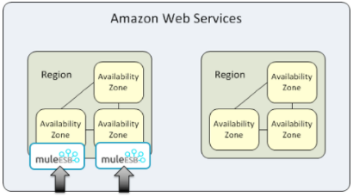

If an application uses a single worker, when the availability zone goes down, it needs to be brought up manually. Alerting can be set up within status.mulesoft.com to receive alerts when a failure occurs in an availability zone or region level.

**Anypoint CloudHub Alternative Deployment Model**

A load balancer (Cloud/On-Premise) can be pointed to apps deployed to different regions to provide a better disaster recovery strategy.

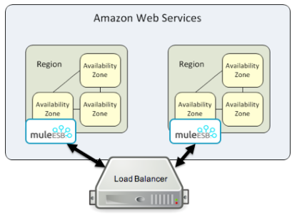

**Keep Integrations Stateless**

As a general design principle, it is always important to ensure the integrations are stateless in nature. This means that no transactional information is shared between various client invocations or the executions (in case of scheduled services). If some data has to be maintained by the middleware due to a system limitation, it should be persisted in an external store such as a database or a messaging queue and not within the middleware infrastructure or memory. It is critical to note that as we scale, especially in the cloud, the state and resources used by each worker/node should be independent of the other worker. This model ensures better performance, scalability as well as reliability.

## Disaster Recovery On-Premise

<<Disaster recovery for on-premise deployments would be driven by the customer’s Enterprise Disaster Recovery plans. If they have any detail out at very high level how can Mule Applications get recovered in the event of disaster and how can the required RTO / RPO achieved>>

## Logging

This section covers how logging should be done using Anypoint Platform and how various logs are accessible using the platform.

## Mule Application Logging

Application message events that should be tracked for Enterprise level Logging are: Inbound, Outbound, Poll, Batch, Security and Other. These are detailed below:

1. **Inbound**: Represents all requests that are made to the application/service/appliance
2. **Outbound**: Represents all requests that are made by the application to other applications/services/appliances.
3. **Poll**: Scheduled job triggers
4. **Security**: All security level events should be captured, such as successful and unsuccessful requests. For JWT Validation, this will be built into the JWT Validation module. For other applications, this will be defined per application, but following the same pattern for easy Auditing purposes.
5. **Audit**: Audit types log events
6. **Exception**: Any exceptions logged as normal, but listed here as messages can be targeted to different log4j appenders.
7. **Batch**: Any batch related integrations where logging is required.
8. **Other**: Represents a catch all for any other events the logging application wishes to log

The event type is specified as a portion of each log record as a part of the log message. The log events must contain sufficient content to enable analysis of the platform’s behaviour from both internal and external perspective. Details include items of technical significance as well as business significance. This content makes up the Fields of the log record.

The Log record Fields are categorized into standard Contexts as below:

1. **Header**

standard identifiers of the log event - application id, event type, timestamp

1. **Application Context**

contains data about the processing platform and application where the event originated and is currently being processed

1. **Service Context**

this is the “what” that is being invoked. It contains technical details of the call (will vary according to event type) – service endpoint, service key, etc,

1. **Actor Context**

the IDs of the actors invoking the call.

1. **Security Context**

security specific information. The fields required here will be defined in the Application Security Logging Guideline.

1. **Service Results**

timings, data size, error codes/messages

1. **Transaction Context (Correlation Id)**

facilitates to achieve end-to-end traceability to ensure inter and intra system transactions are effectively captured for the fault diagnosis. This is typically either passed in from the consumer, or use of the Mule Message Id which is a unique GUID.

All the above requirements are available in a pre-built custom logger module, which will be provided by MuleSoft Professional Services, along with source code should any modifications are required.

## Integrate application logs with external monitoring / analytics tools

<< Provide information on how the logs will get transferred to the interested system, any custom log4j appenders are required etc>>

## Audit Logging

Changes performed by users within Anypoint platform are captured and available via an audit logging service and are Business Group aware. The audit logging services provide a searchable history of actions performed within the Anypoint platform.

Users or system processes perform these actions either via an API call or through the Anypoint user interface. Each Audit log entry has a set of properties that provides us with more information about the activity.

In addition, the Audit Logs are available via APIs, meaning data can be consumed at regular intervals and stored in say a Data Warehouse for Auditing purposes. The Audit Logging API provides the ability to retrieve granular Audit logs. For example, audit logs can be queried via a start date, so logs can be retrieved daily and persisted to a Data Warehouse. Refer to the following link which provides detailed information on log message types and associated payloads: <https://docs.mulesoft.com/access-management/audit-logging>

Audit logs are stored in the Anypoint Platform. User access is fully audited and audit logs are kept for at least 12 months, but this is subject to change. Therefore, audit log data should be persisted.

Refer to the Audit Logging API Portal for further information:

<https://anypoint.mulesoft.com/apiplatform/anypoint-platform/#/portals/organizations/68ef9520-24e9-4cf2-b2f5-620025690913/apis/24562/versions/26089/pages/39847>.

## Security Logging

#### API Policy Violations

Although API Policy violations are application specific, the monitoring of security based API policy violations should be considered a Platform Monitoring requirement since this is a common pattern that will retrieve all API policy violations. The Analytics Events API provides the ability to query, daily, for Policy Violations. These violations can then be stored if required with the help of a custom application that consumes the API.

#### API Usage Data

Again, as with the preceding section above, API usage is application specific, but is covered at a Platform level. Data can be retrieved using the Analytics Events API. Data can then be stored if required using a custom application that consumes this API.

## Alerting / Monitoring

## Anypoint Runtime Manager (ARM) Server Alerts

ARM provides out-of- the-box alerts that trigger the sending of emails whenever certain events related to a CloudHub application occur. At a platform level, alerts should be configured when ARM encounters a problem with a Server or Server Cluster. These setting can be set at a global level, meaning for all APIs deployed to the Parent Organisation and Business Groups. The following conditions should be monitored:

* Servers
  + Server up
  + Server disconnected
  + New server registered
  + Agent’s version changed
  + Runtime’s version changed
  + Server deleted
  + CPU Usage >= <TBD>% for at least <TBD>mins
  + Load average >= <TBD> for at least <TBD>mins
  + Memory Usage >= <TBD>mb for at least <TBD>mins
* Clusters
  + Cluster Created
  + Cluster Deleted
  + Server added to a Cluster
  + Server removed from a Cluster
  + Cluster is up
  + Cluster is down
  + A cluster’s node came up
  + A cluster’s node went down
  + Cluster presents visibility issues

For more information on ARM Alerts, refer to the following link: <https://docs.mulesoft.com/runtime-manager/alerts-on-runtime-manager>

## Mule Runtime Manager Agent

The Alerts described above hook into the Mule Runtime Manager agent. This agent can also be extended to provide monitoring and alerting capabilities beyond those defined in the Alerts User Interface in ARM.

This is a plugin extension for a Mule runtime which exposes the Mule API. Runtime Manager uses this agent to communicate with its registered Mule runtimes on Mule Servers. Outside the Anypoint Runtime Manager, you can use the agent to monitor and control Mule servers by calling APIs from external systems, and/or have the Runtime Agent publish data to external systems.

The agent has many features, including:

* Controlling applications, domains and services:
  + List, deploy, undeploy or redeploy domains.
  + List, deploy, undeploy, get status of, start or stop applications.
* Publishing Mule metrics, from JMX MBean framework to an external monitoring systems.

<< Provide details if there is an integration required to any external monitoring systems>>

## Capacity Planning

Following are the considerations that need to be made while planning for the capacity.

To estimate the memory consumption of an application, estimating the overall amount of information that each individual message will store as it goes through the flows which includes payload, properties & variables. As messages mutate while they go through flows, take as message size the largest one possible. This will ensure that even in the worst-case scenario will not run into out of memory.

Once the largest message size of the application is estimated, multiply it by the number of messages application is configured to support simultaneously. The product of message size times the number of messages in transit will give a starting point for memory requirements.

A Mule Application consists of flows which in turn contain one or many endpoints. To estimate the memory requirements for a Mule Application, the following steps need to be carried out:

1. Determine all the endpoints (e.g. Receivers & Triggers) that are embedded within the application.
2. Estimate the memory required for each of these endpoints. The memory required for each endpoint can be estimated using three parameters:

Using the above, the memory for each endpoint = (A x B x C) where:

A - The throughput on this endpoint (Number of triggers over time)

B - The size of data for each trigger = (Incoming Message Size + Flow Data Size)

C - The interval time = The estimated time to execute each request (trigger)

The total memory required for the application is the sum of the above plus a 300M requirement for the JVM initialization. The JVM initialization should also include any data that is loaded into memory on startup.

Based on the memory calculation, estimate of the CPU cores can be defined using the following assignment as a reference:

<https://docs.mulesoft.com/runtime-manager/cloudhub-architecture>

Worker Sizes:

* 0.1 vCores + 500 MB Memory
* 0.2 vCores + 1 GB Memory
* 1 vCores + 1.5 GB Memory
* 2 vCores + 3.5 GB Memory
* 4 vCores + 7.5 GB Memory